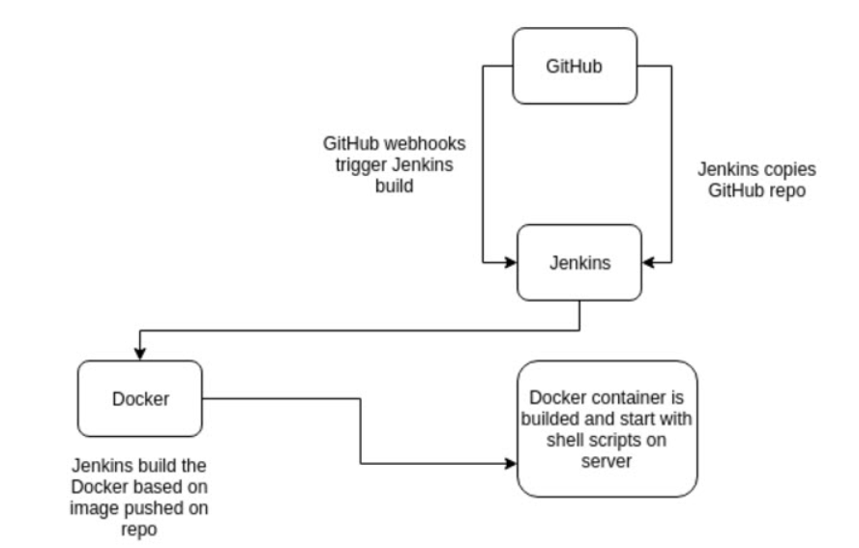

<https://www.stratoscale.com/blog/devops/practical-devops-use-case-github-jenkins-docker/>

# **A Three Part Process**

The CI workflow described in this article is composed of three steps. The developer first pushes a commit to GitHub, which in turn uses a webhook to notify Jenkins of the update. Jenkins can then pull the GitHub repository, build the Docker container which contains our stack and then run the test. If the test passes, Jenkins will push the code to the master branch.

The build is done using writing shell scripts in the jenkins free style project

in the above pipeline we create a docker file in which we pull the LAMP stack image and mention all the dependencies.

So based on the base image pulled by using docker file . on top of the base image we build an container and run .

rm -rf *

sudo yum remove docker -y

sudo yum install docker -y

sudo service docker start

git clone https://github.com/suryarayala/docker_jenkins_LAMP

cd docker_jenkins_LAMP

sudo docker build -t lamp_image .

sudo docker run -p 80:80 -p 3306:3306 lamp_image

we need to add Jenkins user to sudoers because Jenkins should have the rights to run shell scripts of docker .